FARM MANAGEMENT SYSTEM

Topic : Farm Management System
College : Sangahamam college of arts and scince
Department : BCA
Team Name : Farm Savers
Members : Santhsh,Sathish kumar,Saranraj

Summary :

In the Farm Management System (FMS), as a farmer, farm manager, or system administrator, I want to use a centralized Salesforce-based platform to record and manage farm, crop, farmer, and buyer information so that all agricultural data is stored securely and systematically. I want to enter and update farm details, crop production records, and buyer transactions easily through a user-friendly interface with proper validation rules to prevent incorrect entries. I also want the system to generate real-time reports and interactive dashboards so that I can analyze farm productivity, monitor sales, and make informed decisions. Additionally, I want role-based access and secure data storage to ensure that sensitive information is protected while enabling smooth collaboration among users. This system will help reduce manual paperwork, minimize errors, improve efficiency, and support data-driven farm management.

- INTRODUCTION

  - Project Overview :

The Farm Management System (FMS) is a Salesforce-based application designed to digitize and streamline agricultural operations. It manages data related to farms, crops, farmers, and buyers while providing real-time insights through reports and dashboards. The system helps farmers and managers monitor agricultural activities efficiently and make informed decisions

  - Purpose :

The main purpose of this project is to:
● Digitize agricultural data management
● Improve data accuracy and accessibility
● Automate record handling
● Enable real-time monitoring
● Support data-driven farming decisions
● Enhance productivity and transparency

- IDEATION PHASE

  - Problem Statement(Customer Problem Statement Template) 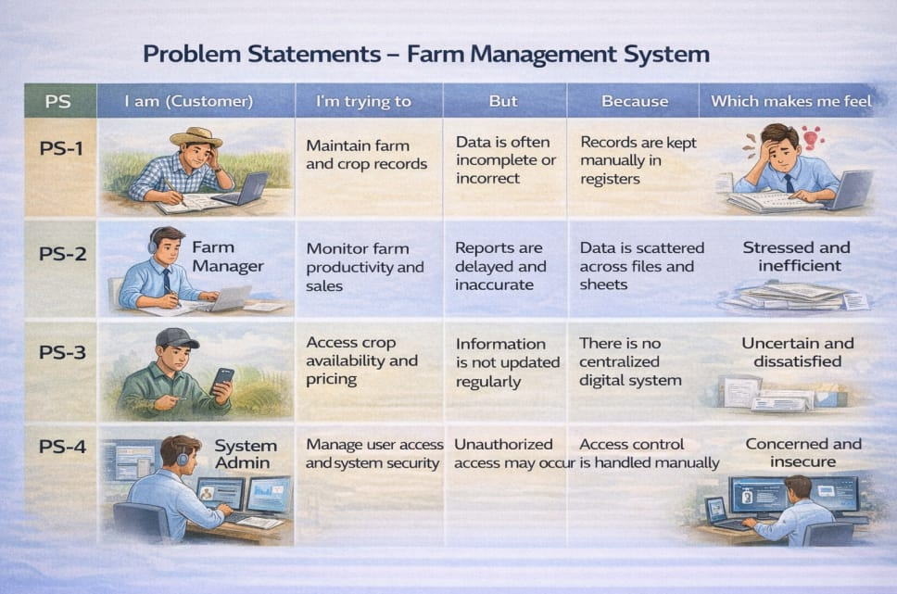
2.2 Empathy Map Canvas Target Users:
● Farmers
● Farm Managers
● Buyers
● System Administrators
Empathy Analysis
● Think & Feel: Need accurate and timely farm data
● Hear: Feedback from agricultural officers
● See: Registers, paper files, spreadsheets
● Say & Do: Enter records manually
● Pain: Data loss, errors, delays
● Gain: Automation, fast reportin

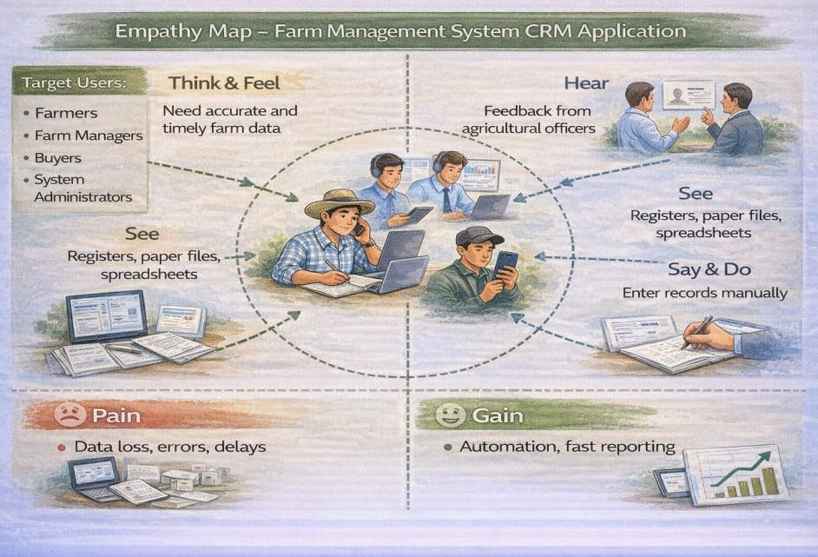

  - Brainstorming
  - Brainstormed Ideas
● Manual farm records
● Excel-based management
● Web-based system
● Mobile farm app
● Salesforce-based FMS
Selected Idea
Salesforce-based Farm Management System
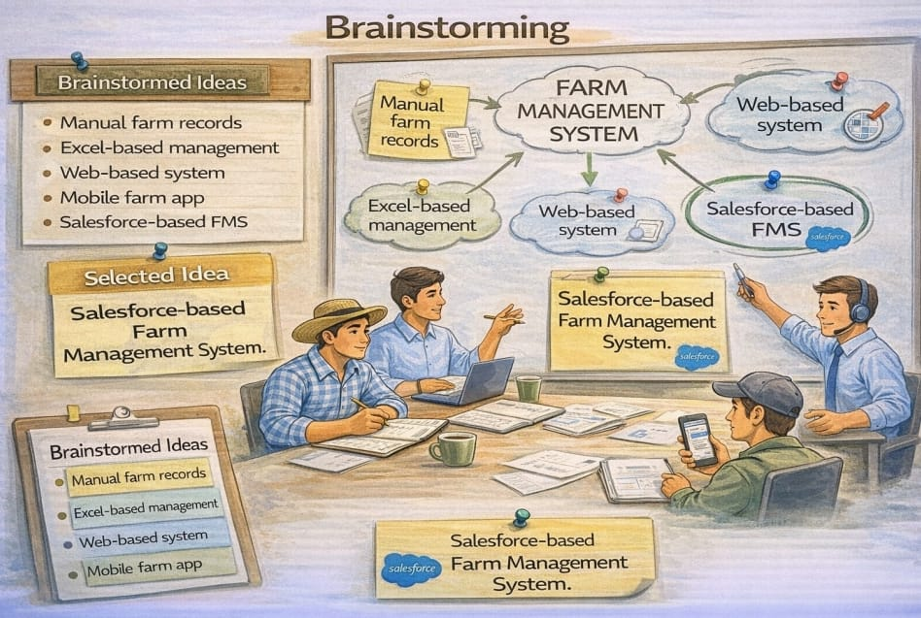
3.REQUIREMENT ANALYSIS PHASE
3.1 Customer Journey Map
Stages:
1. Login
2. Access Farm Management App
3. Enter Farm and Crop Data
4. Register Farmers and Buyers
5. Generate Reports
6. Analyze Results
7. Decision Making
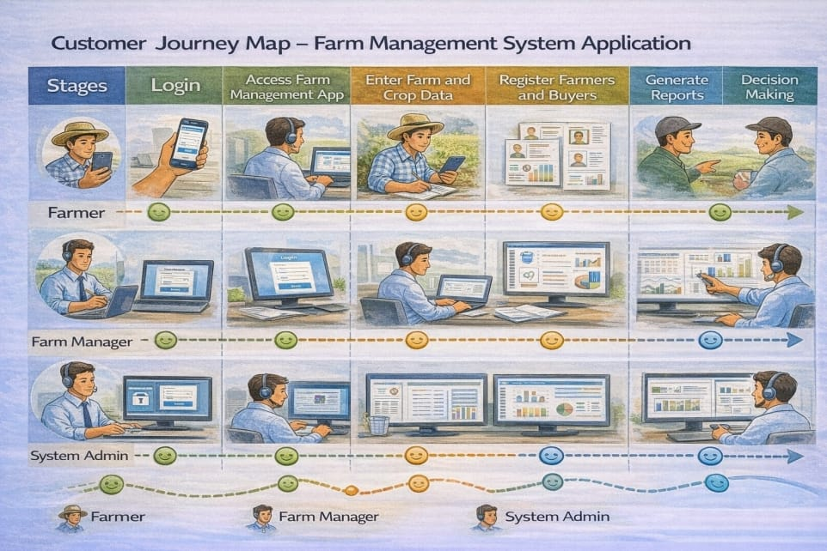
3.2 Solution Requirements
Functional Requirements

FR no | Requirement
FR-1 | User Authentication
FR-2 | Farm, Crop, Farmer, Buyer Management
FR-3 | Data Entry and Validation
FR-4 | Relationship Mapping
FR-5 | Report Generation
FR-6 | Dashboard Visualization
FR-7 | User Role Management

3.3 Data Flow Diagram Data Flow:
User → Salesforce UI → Custom Objects (Farm, Crop, Farmer, Buyer) → Validation Rules → Relationships → Reports → Dashboards
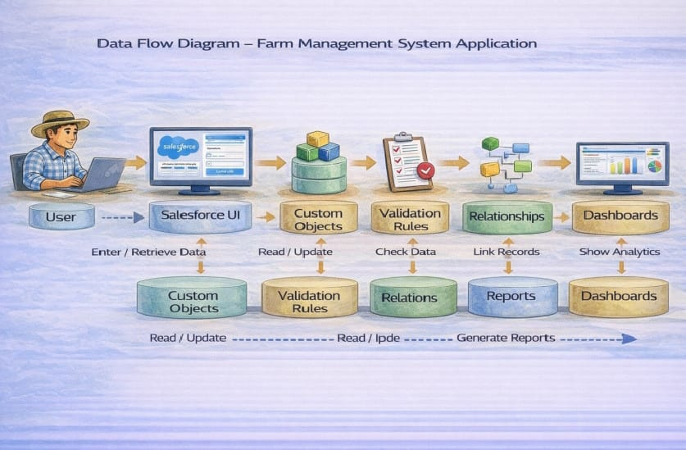

3.4 Technology Stack
Layer | Technology
Frontend | Salesforce Lightning UI
Backend | Salesforce Platform
Database | Salesforce Cloud
Automation | Validation Rules
Analytics | Reports & Dashboards

4. PROJECT DESIGN PHASE
4.1 Problem–Solution Fit The FMS replaces manual farming records with automated data management. Cloud storage prevents data loss, dashboards improve analysis, and real-time reports eliminate delays. This ensures accurate and timely agricultural insights.
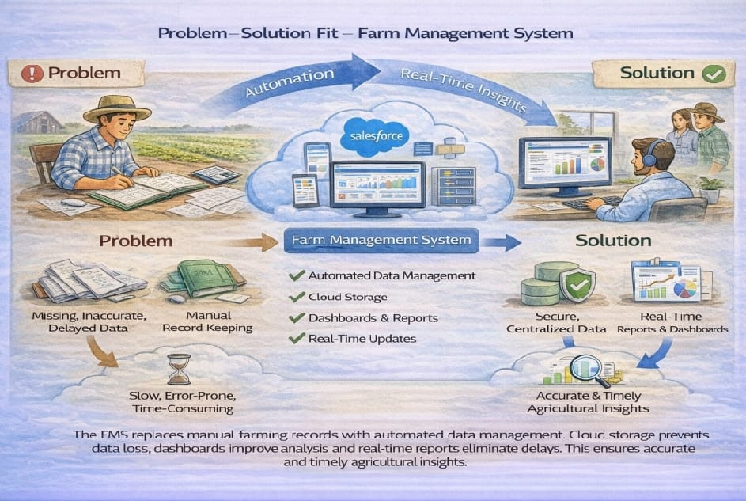
4.3 Solution Architecture
Architecture Layers
1. Presentation Layer – Salesforce Lightning UI
2. Application Layer – Validation Rules, Relationships
3. Data Layer – Custom Objects
4. Analytics Layer – Reports and Dashboards

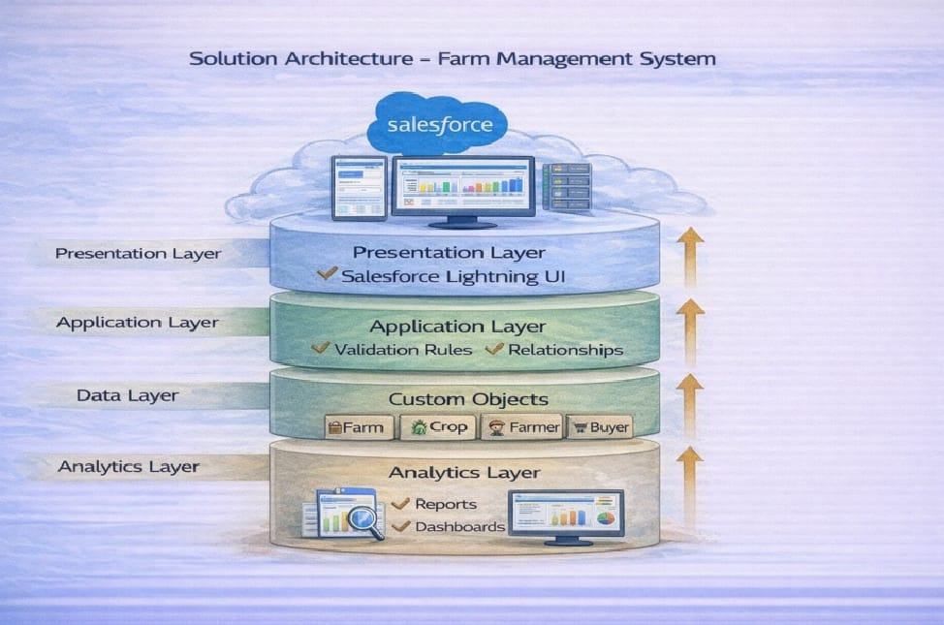
5. Project Development Phase:
Project Description:
The Farm Management System (FMS) in Salesforce is a comprehensive solution designed to digitize and streamline agricultural operations. This application empowers farmers, farm managers, and stakeholders by managing data related to crops, Farm, Farmer, and buyers, while providing actionable insights through reports, and dashboards.
Milestone 1-Salesforce:
What Is Salesforce?
Salesforce is your customer success platform, designed to help you sell, service, market, analyze, and connect with your customers. Salesforce has everything you need to run your business from anywhere. Using standard products and features, you can manage relationships with prospects and customers, collaborate and engage with employees and partners, and store your data securely in the cloud.

6)Functional & Performance Testing
They are 6 function in this project
1)Farm
2)Farmers
3)Crops
4)Buyers
5)Reports
6)Dashbords, and we have a images for that they are

1)Farm

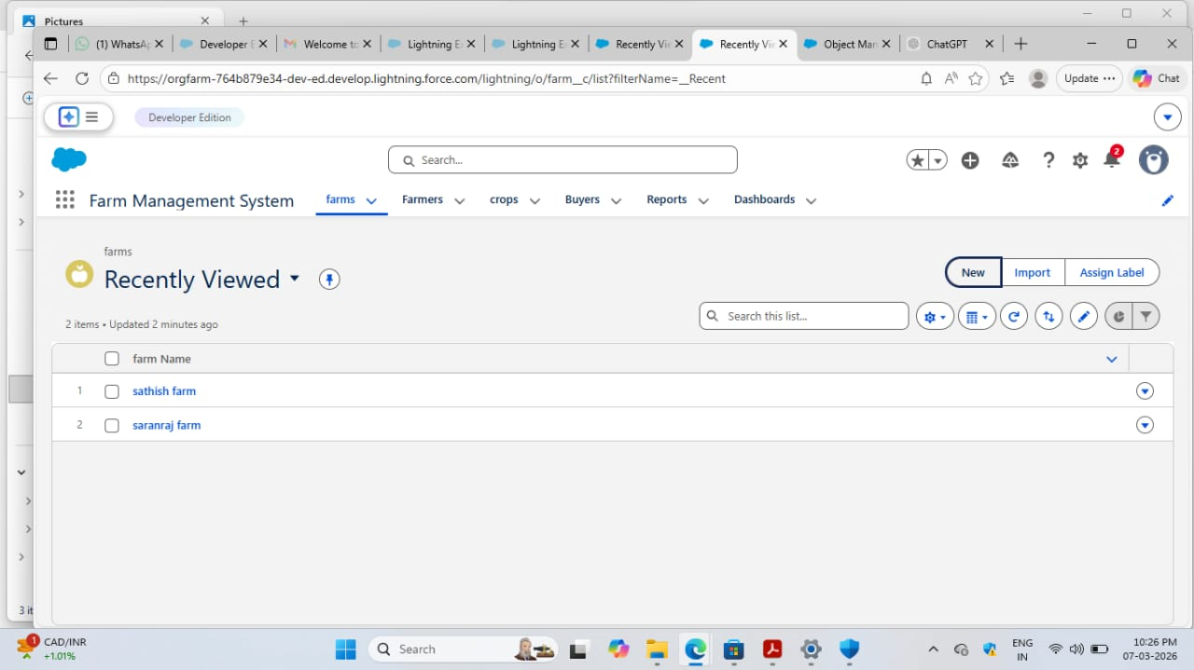
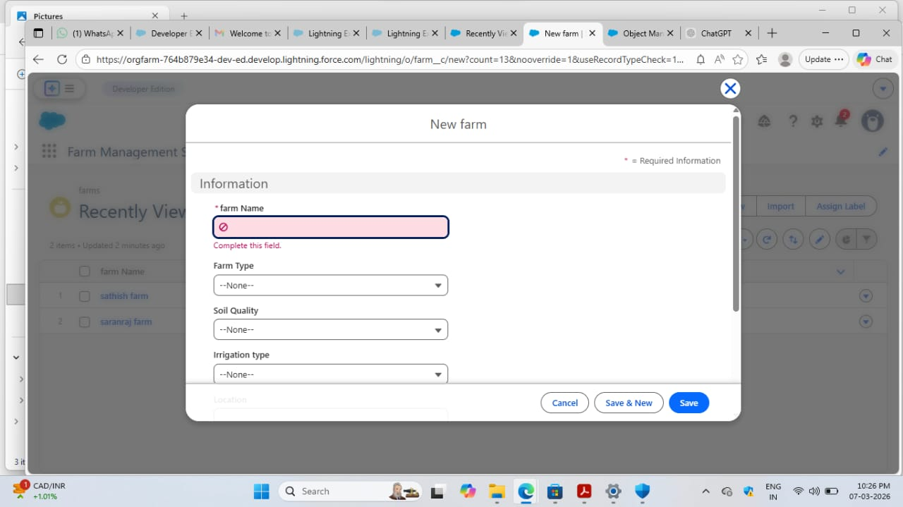
2)Farmers
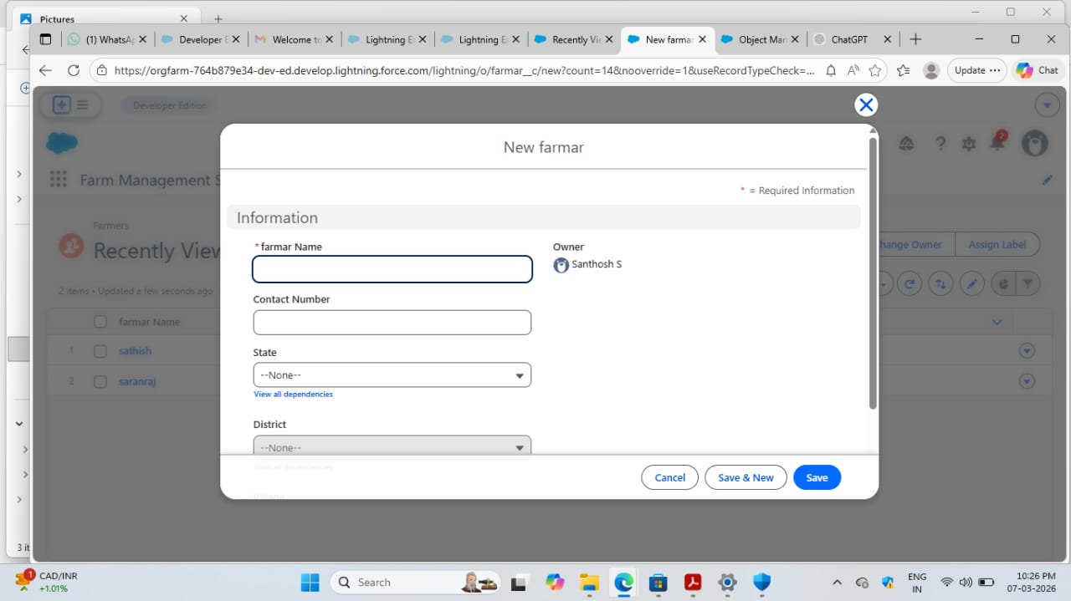

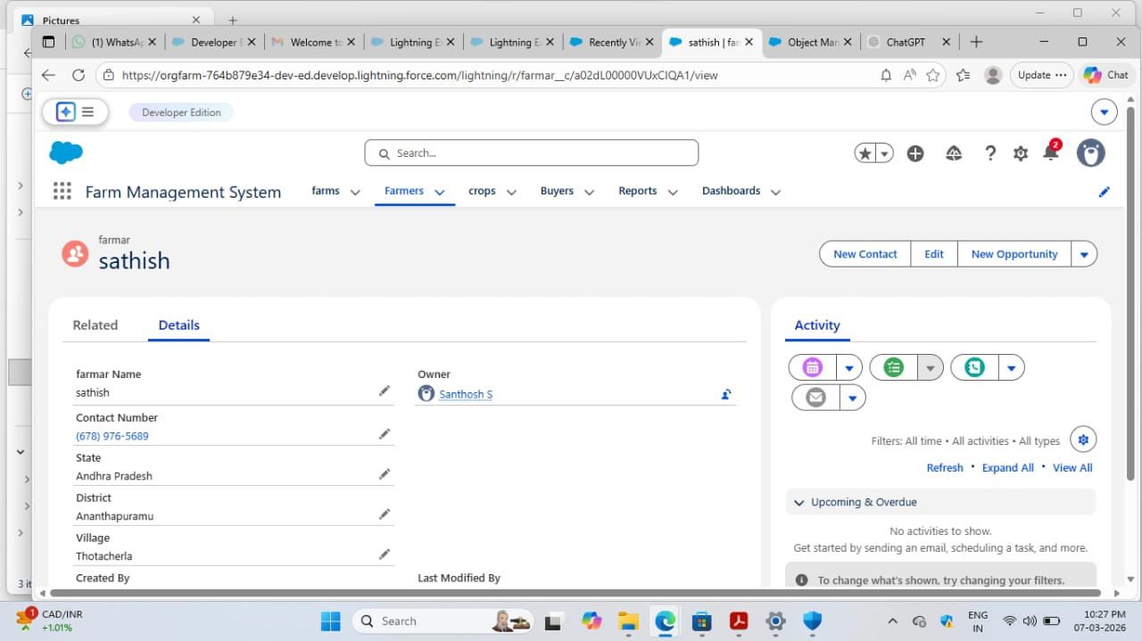
3)Crops
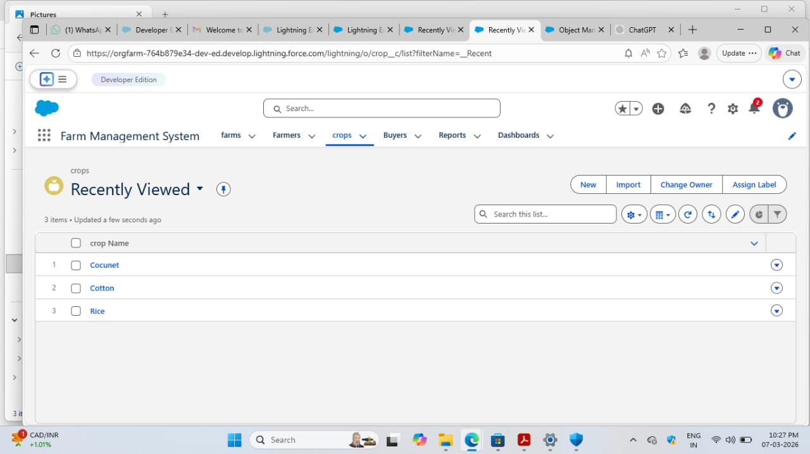

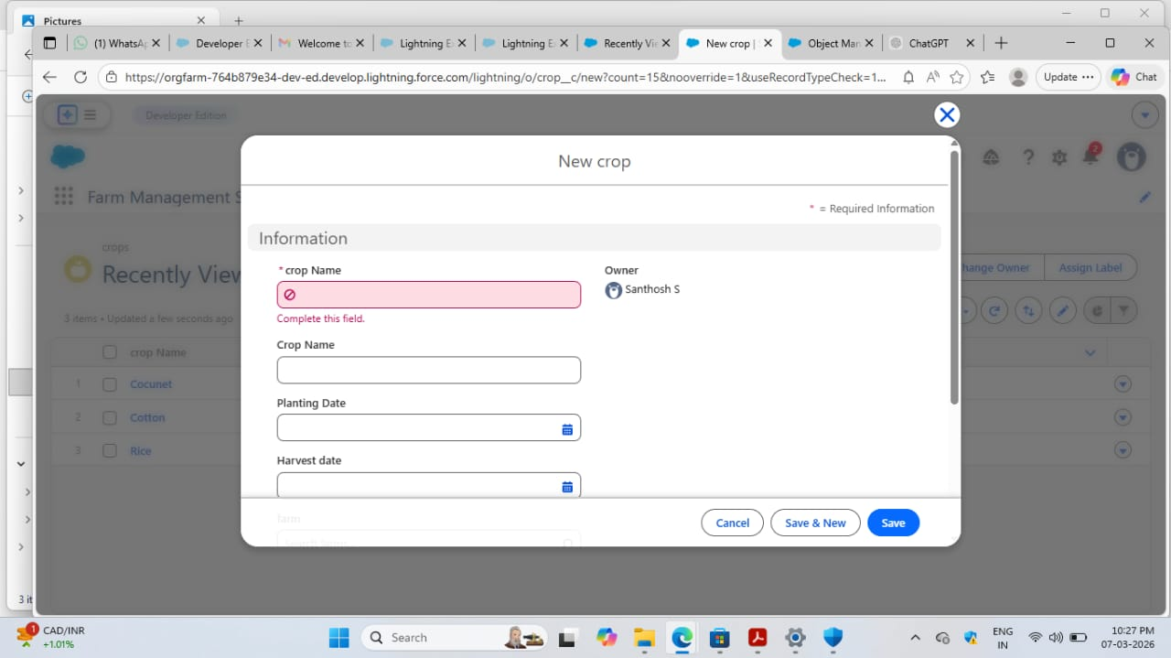
4)Buyers
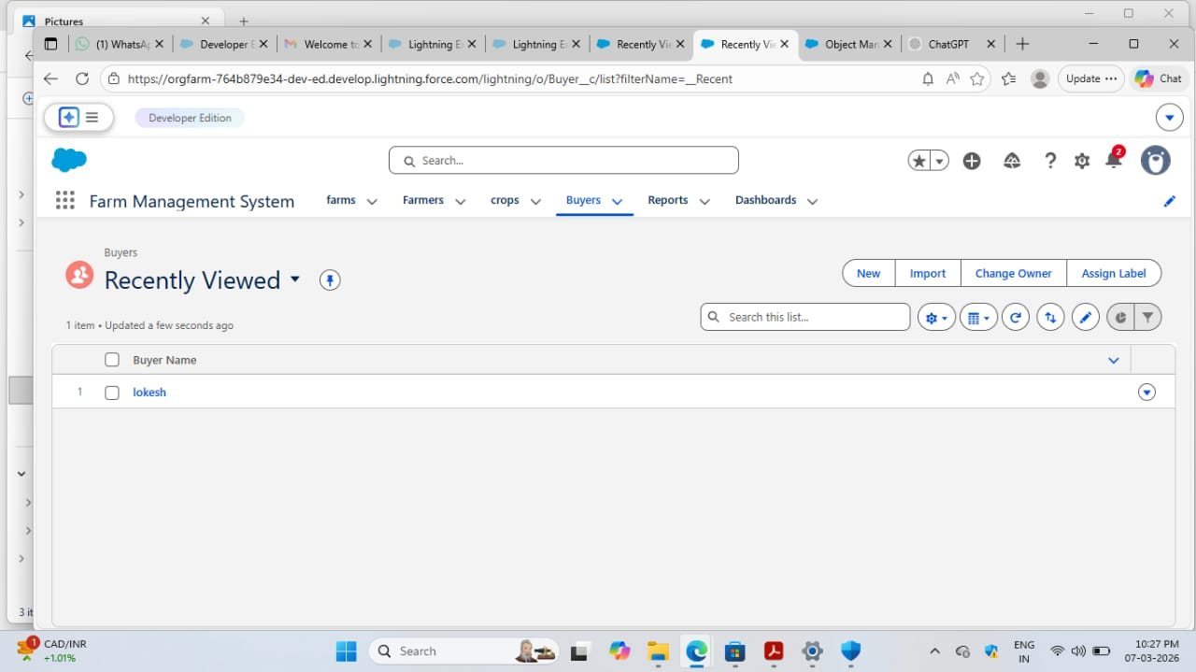

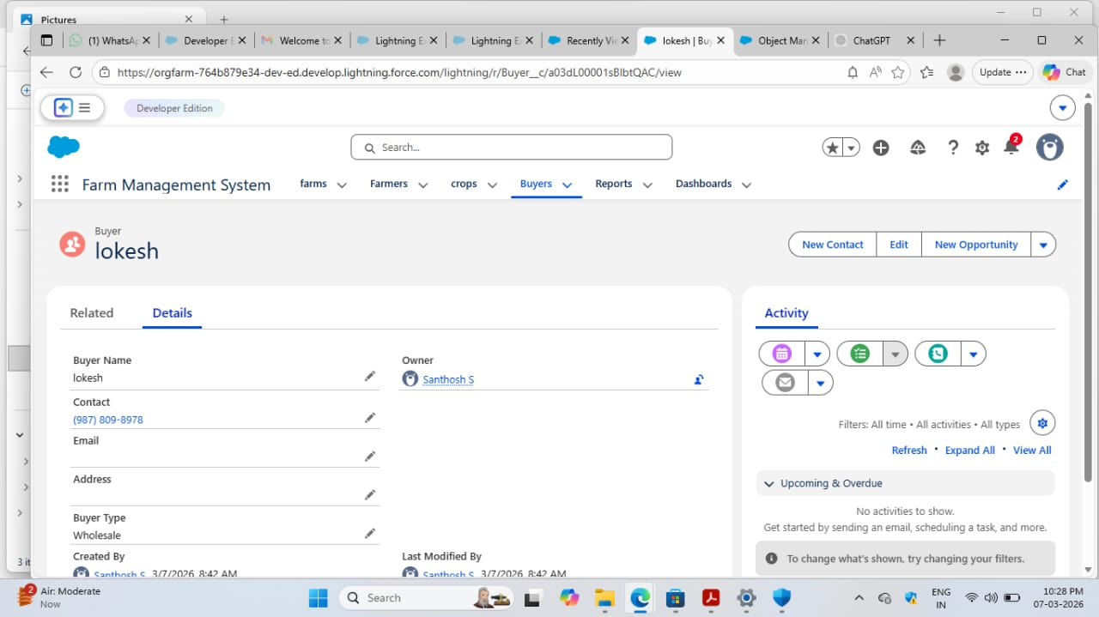

5)Reports
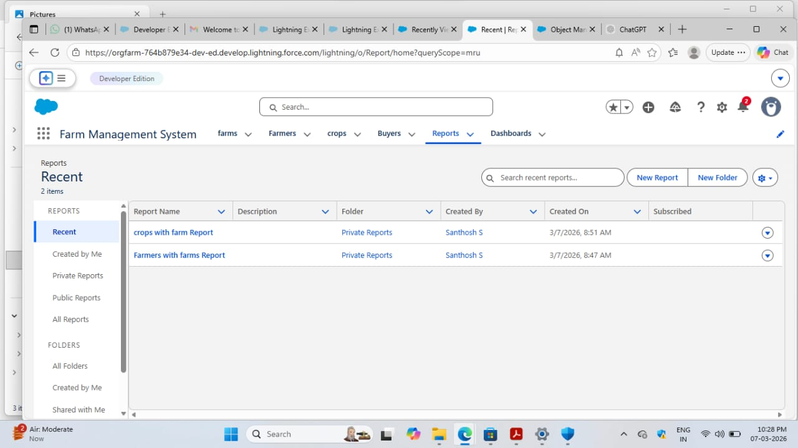

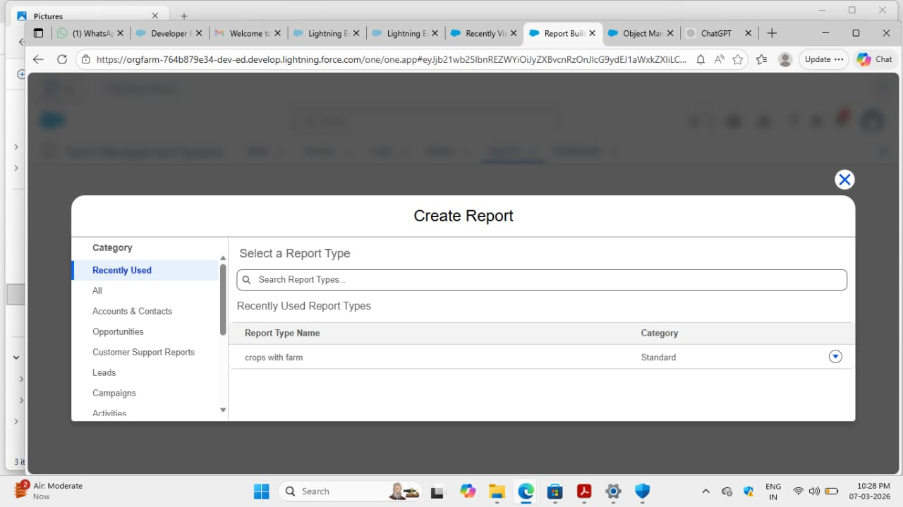

6)Dashbords
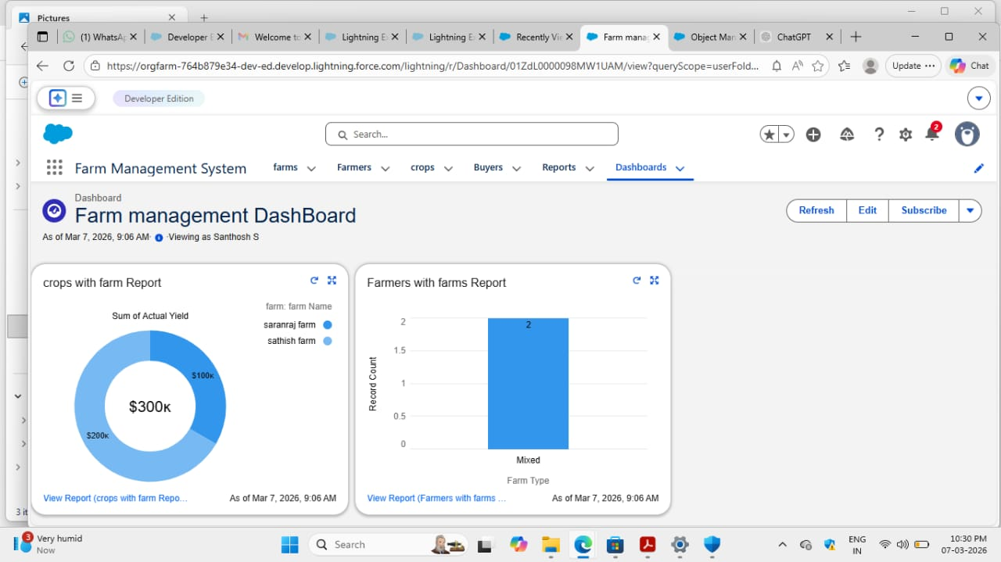

7. Conclusion:
The Farm Management System successfully digitizes agricultural data management using Salesforce. It improves efficiency, reduces errors, and enables farmers and managers to make informed decisions through automation and analytics.

THANK YOU

